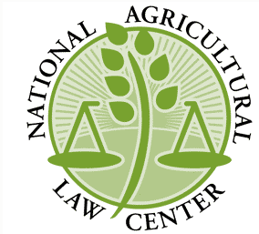
The Nation’s Leading Source for Agricultural and Food Law Research and Information
THE NATIONAL AGRICULTURAL LAW CENTER
www.NationalAgLawCenter.org

Elizabeth R. Springsteen J.D., LL.M.
Phone: (479) 387-2331 | Fx: (479) 575-5830 | Email: esprings@uark.edu
1 University of Arkansas, 107 Waterman Hall, Fayetteville, AR 72701

CERTIFICATE OF ATTENDANCE

1. Program: 8th Annual Mid-South Agricultural & Environmental Law Conference

2. Location: Online Program

3. Dates: May 26th, June 10th and 11th, 2021

Agenda:
Wednesday – May 26th
11:00 – 1:00 pm Ag & Environmental Law Update for the Mid-South 120 minutes
Thursday – June 10th
12:00 – 1:00 pm Moving Through COVID and Trade Wars: Mid-South Ag Lending Outlook 60 minutes
1:00 – 2:00 pm USDA Farm Program Eligibility & Appeals: Pitfalls and Pointers 60 minutes
2:10 – 3:10 pm Looking Back: Reflections from USDA General Counsel 60 minutes
Friday – June 11th
12:00 – 1:00 pm Carbon Credit Markets and Ag: Looking Ahead and What You Need to Know 60 minutes
1:00 – 2:00 pm Legal Ethics in Agricultural Law 60 minutes
2:10 – 3:10 pm Ag Tax & Estate Planning Update 60 minutes

Total minutes attended (maximum 480 minutes) :_________

By signing below, I certify that I attended the activities described above and I am entitled to claim:

_______ general credit hours, based on __50 __60 minute hours, and ___ hour(s) of Ethics credit.

State & Bar Number Add’l. State & Bar Number

Signature: Date: ___________________________________

Printed Name: ____________________________________________________

Address: _______________________________________________________________________________________
City State Zip Code
This conference is approved in Arkansas, Kansas, Mississippi, Missouri, and Tennessee.

